Anthony Redamonti

Syracuse university

Lab 2

CSE-644 Internet security

Dr. Syed shazli

2/8/2023

Task 1: Using Firewall

Machine A (IP 10.0.2.5) is on the same network as machine B (10.0.2.7). Below demonstrates a successful telnet command from machine A to machine B.

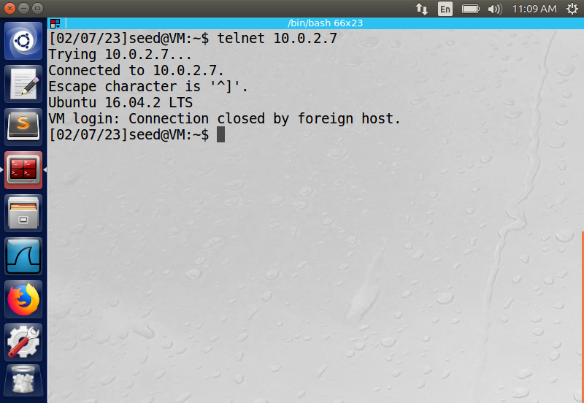

The following command was used to add a rule to the Linux iptables of machine A:

“sudo iptables -A OUTPUT -s 10.0.2.5 -d 10.0.2.7”

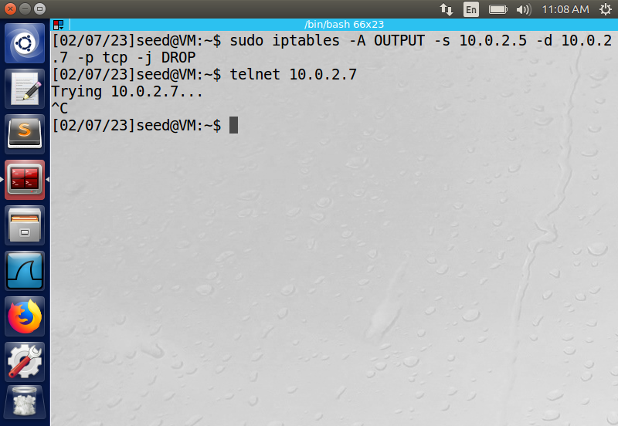

The rule prevented machine A from telnetting into machine B (egress).



The following command was used to add a rule to the Linux iptables of machine A:

“sudo iptables -A INPUT -s 10.0.2.7 -d 10.0.2.5 -p tcp -j DROP”

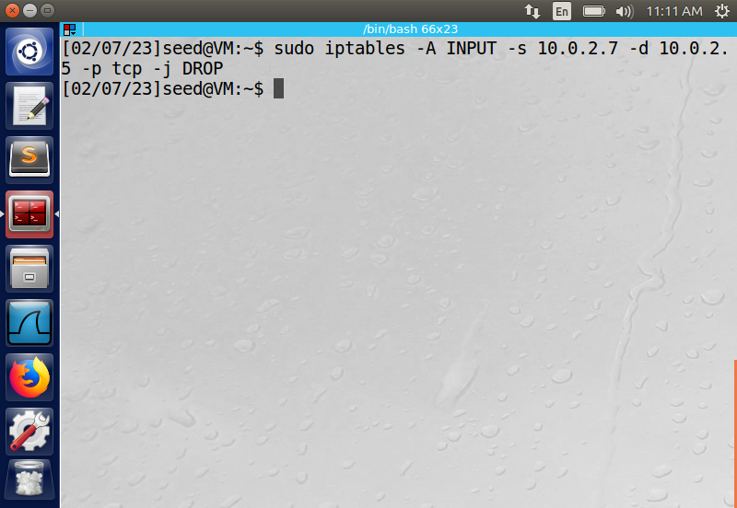

The rule prevents machine B from telnetting into machine A (ingress).

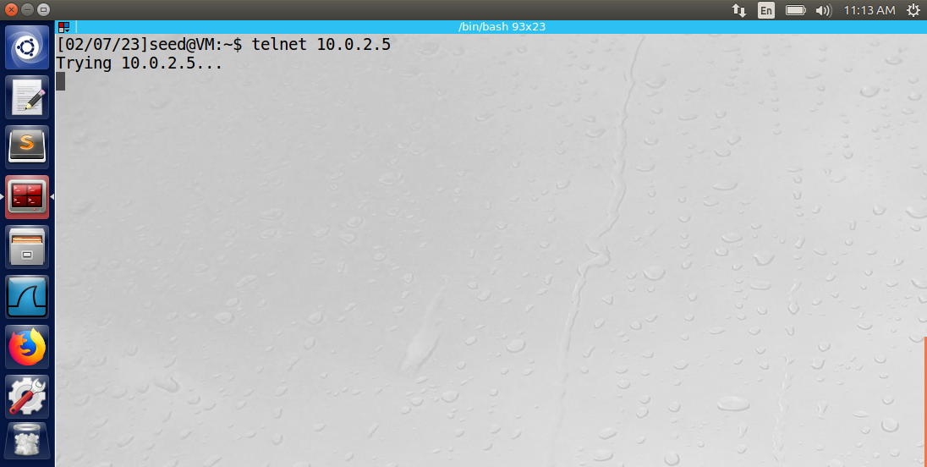

Machine A could successfully send a PING request to www.example.com.

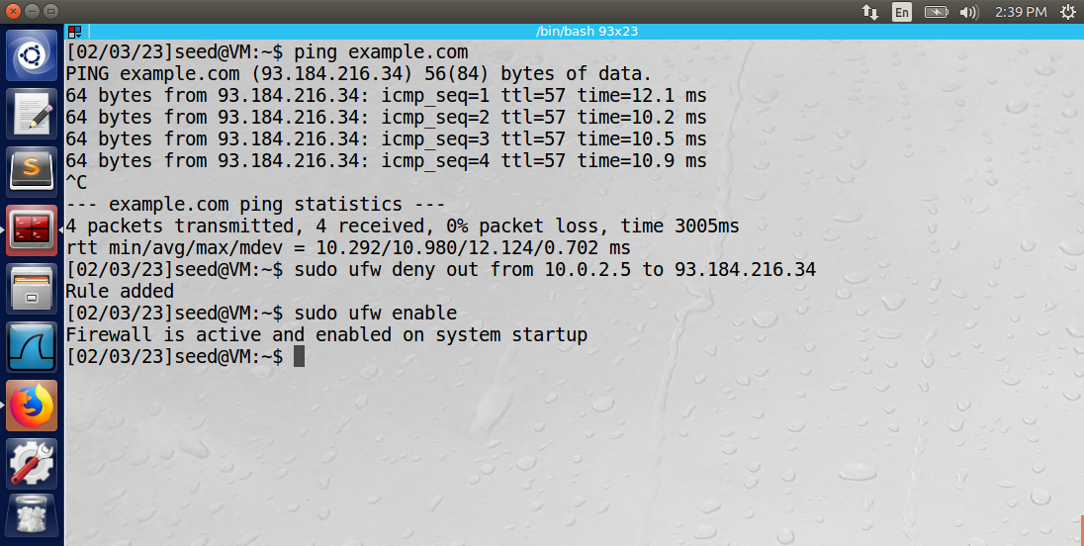

The following command was used to add a rule to the Linux iptables of machine A:

“sudo ufw deny out from 10.0.2.5 to 93.184.216.34” followed by “sudo ufw enable”



The PING command from machine A to www.example.com is no longer permitted.

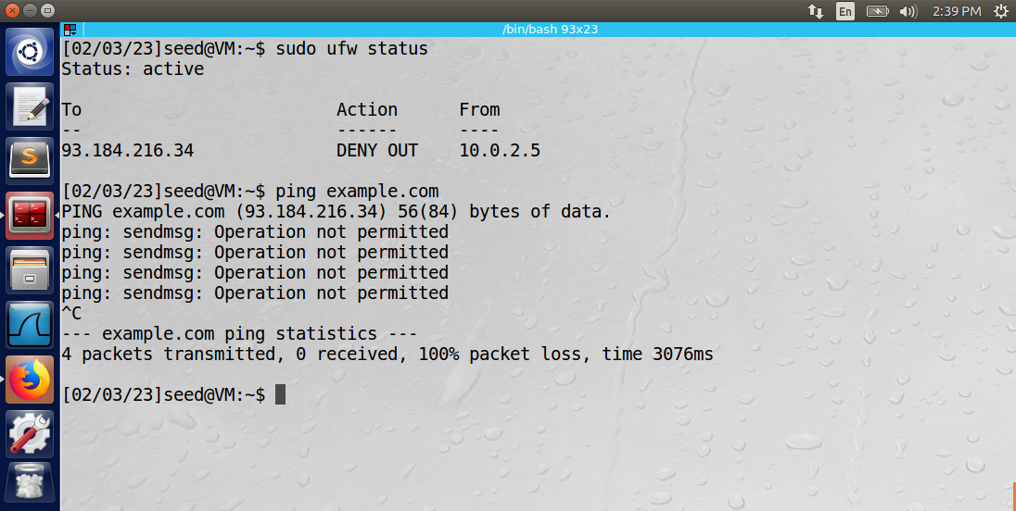

Observation: After the rules were added to the iptables, the Linux kernel used them to block ingress or egress traffic. The INPUT keyword is used to specify ingress traffic, and the OUTPUT keyword is used to specify egress traffic.  
Explanation: The sudo keyword must be used to grant access to the iptables. The destination and source IP addresses were specified in each command. The UFW resides in the front-end of the iptables. It was used to block the egress traffic to www.example.com. UFW uses a slightly different syntax than the “iptables” commands. It must be activated using the “sudo ufw enable” command.

Task 2: Implementing a Simple Firewall

The file, “task2.c” is in the appendix section of the lab. It contains the C code to implement a loadable kernel module (LKM) using the Netfilter mechanism. The LKM allows the addition of firewall rules at specific points in the operating system without needing to recompile the kernel.

Rule 1: Block all ICMP echo requests to 10.0.2.7.   
Rule 2: Block all ICMP echo requests from 10.0.2.7.  
Rule 3: Block all telnet commands to 10.0.2.7.  
Rule 4: Block all telnet commands from 10.0.2.7.  
Rule 5: Block all telnet commands from 10.0.2.6.

The make file “Makefile” was used to compile the task2.c file, build the module, and create the task2.ko file.

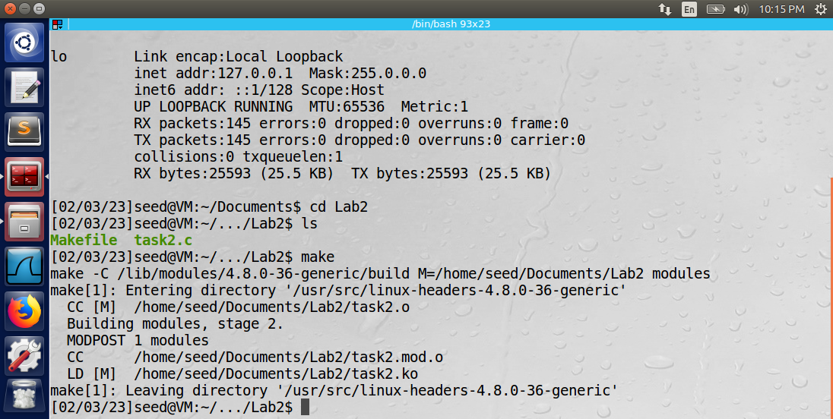

After running the make file, the module is ready to be inserted into the kernel using the “sudo insmod task2.ko” command.

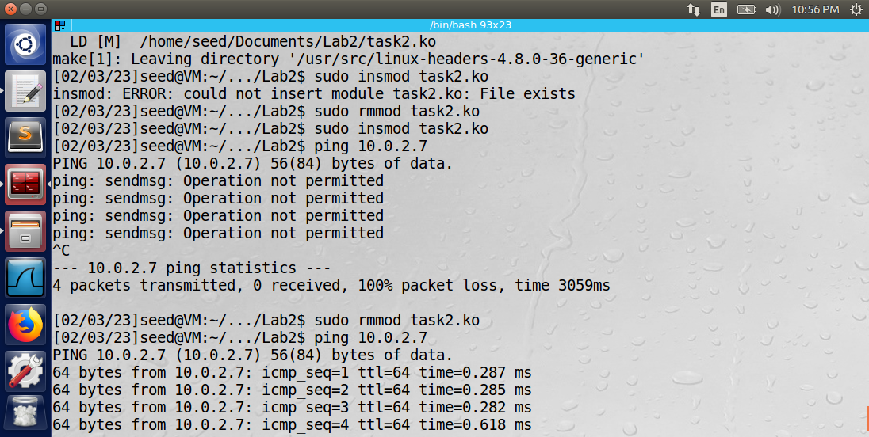

Notice that pinging 10.0.2.7 is not permitted (rule 1). To remove the module from the kernel, use the “sudo rmmod task2.ko” command.



Notice that pinging 10.0.2.7 is now permitted because the module is not inserted into the kernel.

After inserting the module into the kernel, all five of the firewall rules were enforced.

Rule 1: Block all ICMP echo requests to 10.0.2.7.



Rule 2: Block all ICMP echo requests from 10.0.2.7.

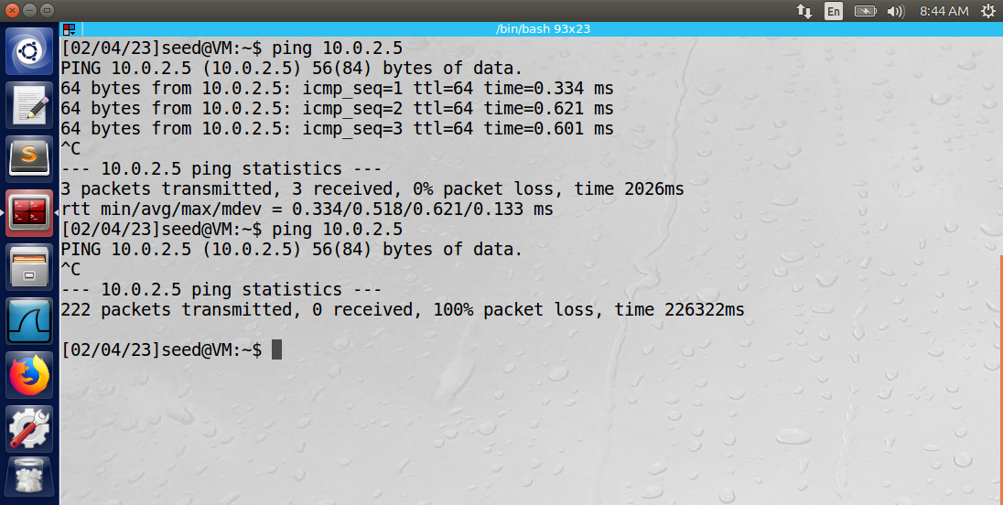

Rule 3: Block all telnet commands to 10.0.2.7.

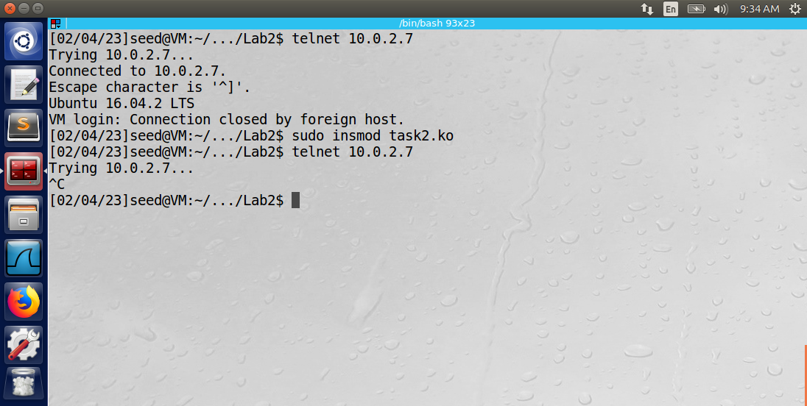

Rule 4: Block all telnet commands from 10.0.2.7.

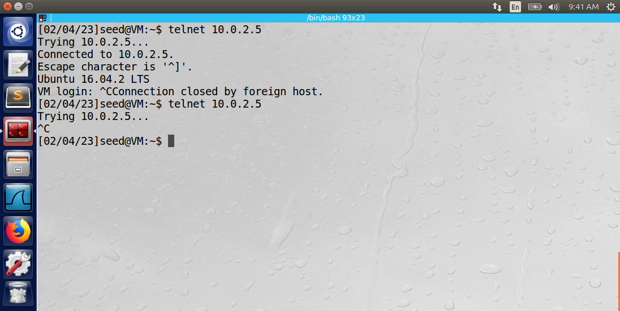

Rule 5: Block all telnet commands from 10.0.2.6.

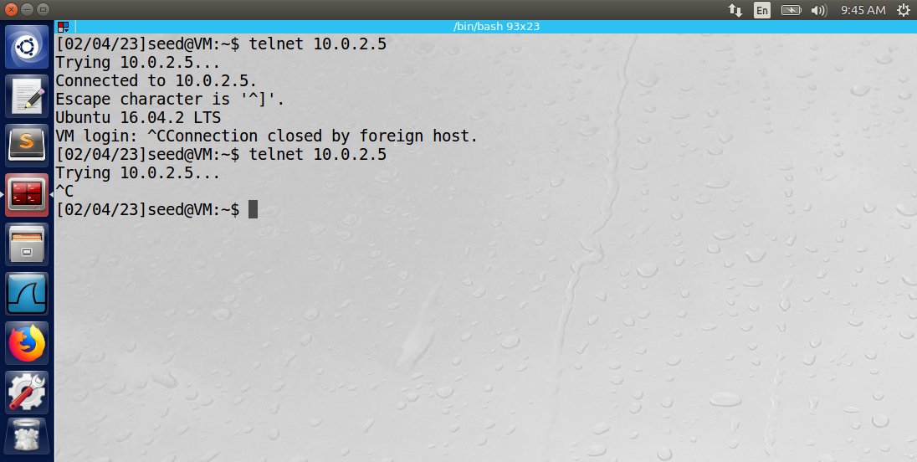

Observation: The use of hooks is used to insert these rules into specific places along the packet paths. The firewall can run the packets through the firewall after the module has been built and inserted into the kernel.

Explanation: A Loadable Kernel Module (LKM) is very convenient when creating firewall rules. The convenience is that the kernel does not need to be recompiled after the rules are inserted. In essence, the Linux kernel does not need to be modified to implement new firewall rules. Note: at the beginning of the Netfilter C application, each hook must be registered using the nf_register_net_hook() function, which registers the hook and all its contents into the module. At the end of the Netfilter C application, the nf_unregister_net_hook() function needs to be called to remove the hooks from the module. In the hooknum data member of the hook class, use NF_INET_LOCAL_OUT to specify egress traffic and NF_INET_LOCAL_IN to specify ingress traffic. Use the hook.hook() method to hook a custom function that parses the packet and returns either NF_ACCEPT or NF_DROP. The iph->saddr is used in the custom function to specify the source address of the IP header and iph->daddr is used to specify the destination address in the IP header.

Task 3: Evading Egress Filter

Before implementing the firewall rules, machine A could telnet to other machines on its network and reach “www.syr.edu” via the internet.

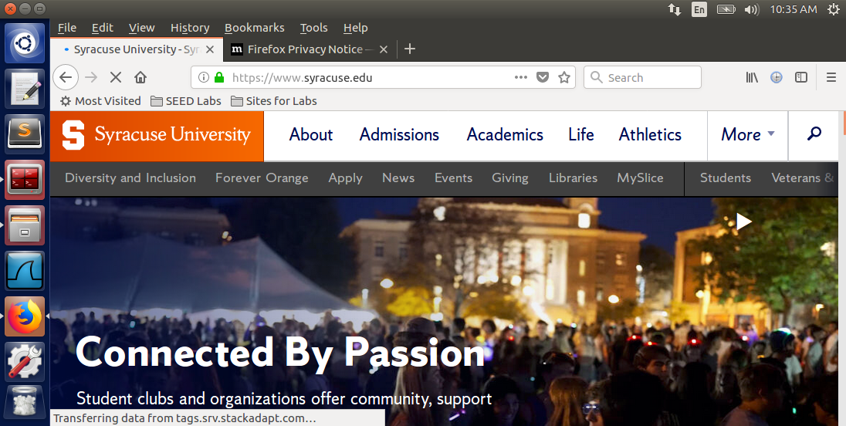

The following rule was implemented on machine A to block all outgoing traffic to telnet servers:

“sudo iptables -A OUTPUT -p tcp --dport 23 -j DROP”

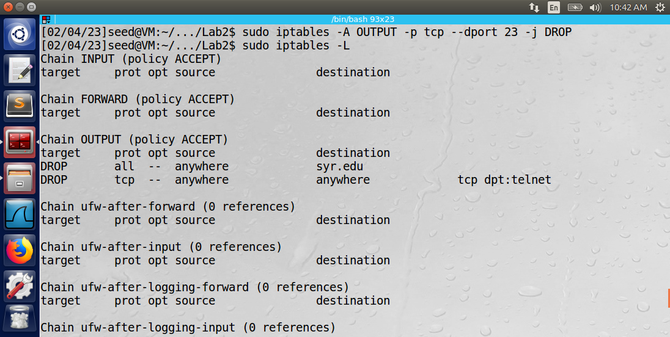

The rule prevented the machine from telnetting to machine B.

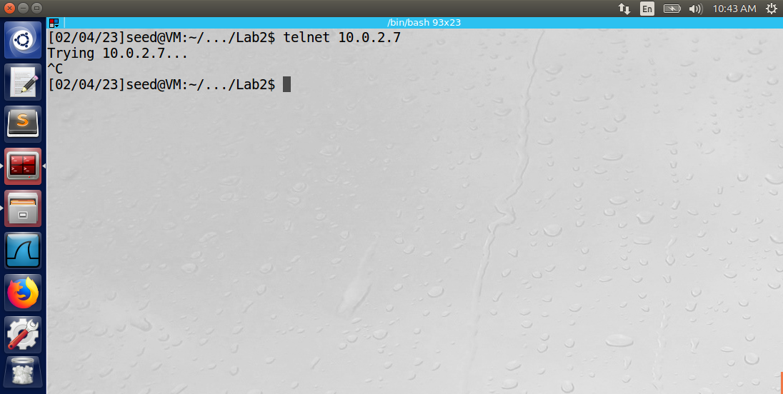

The following rule was implemented to prevent machine A from accessing “www.syr.edu”:

“sudo iptables -A OUTPUT -d 128.230.18.63 -j DROP”

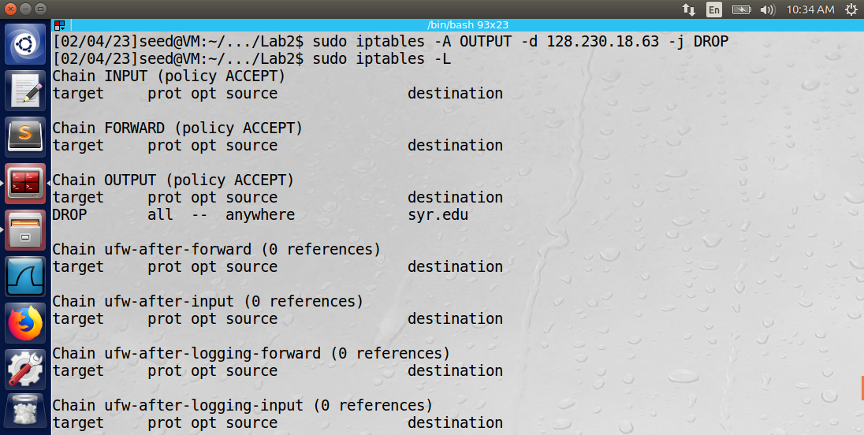

The dig command was used to retrieve the IP address of www.syr.edu. Then the IP address was used as the destination address to target in the firewall rule blocking egress traffic. After the rule is inserted into the iptables, www.syr.edu was no longer reachable via the internet.

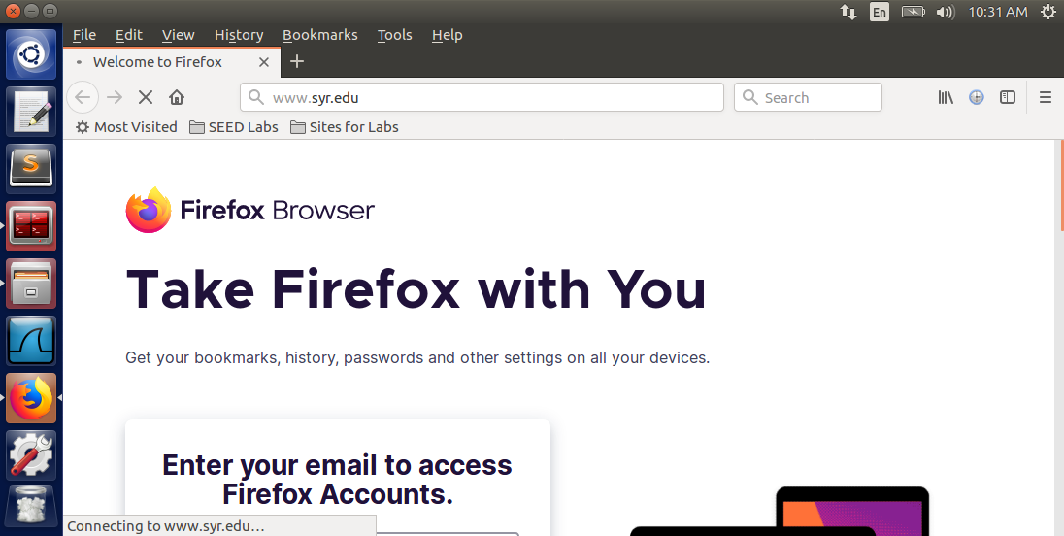

**Part A: Telnet to Machine B through the firewall**

To bypass the firewall, an SSH tunnel was established from machine A to machine B. The SSH tunnel encrypts the packets so that the firewall rules will no longer block TCP packets using port 23 (telnet commands).

The following command was used to set up the SSH tunnel:

“ssh -L 8000:10.0.2.7:23 10.0.2.6”

An SSH tunnel is created with port 8000 of the localhost (machine A) and 10.0.2.6 (machine B). By creating an SSH tunnel with this port, all the TCP packets will be encrypted and sent to 10.0.2.6. The traffic is then transferred from machine B to machine C (10.0.2.7) via port 23 (telnet).

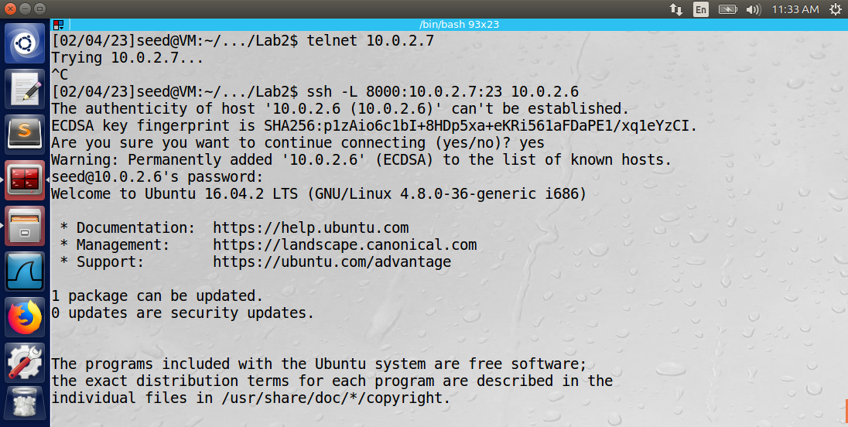

A Wireshark log of the network traffic from machine A is below.

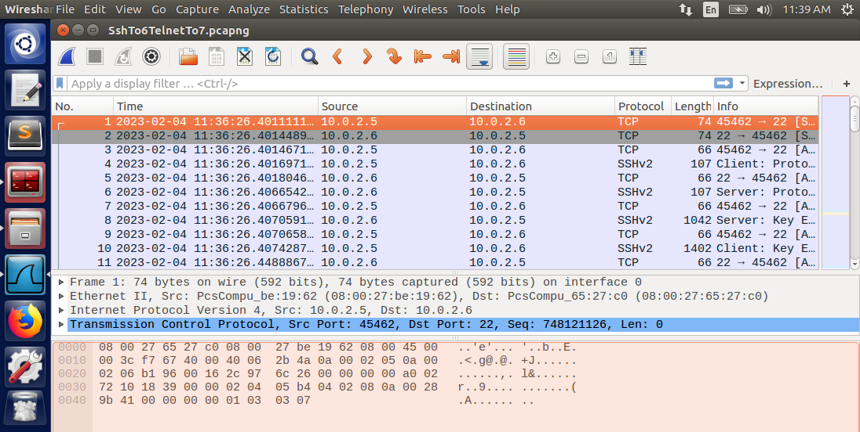

Observation: The Wireshark log displays the packets using the SSHv2 protocol between the client (machine A) and the server (machine B). Between each SSHv2 message is an SSH tunneling packet (TCP) between port 22 or machine B and port 45462 of machine A.

Explanation: By encrypting the packets using an SSH tunnel with machine B, machine A was able to successfully telnet into machine C from machine B.

**Part B: Connect to WWW.SYR.EDU Using SSH Tunnel**

The following command was used to establish an SSH tunnel between machine A and B to bypass the firewall on machine A:

“ssh -D 9000 -C 10.0.2.6”

The command sets up dynamic port forwarding to port 9000 on the localhost.

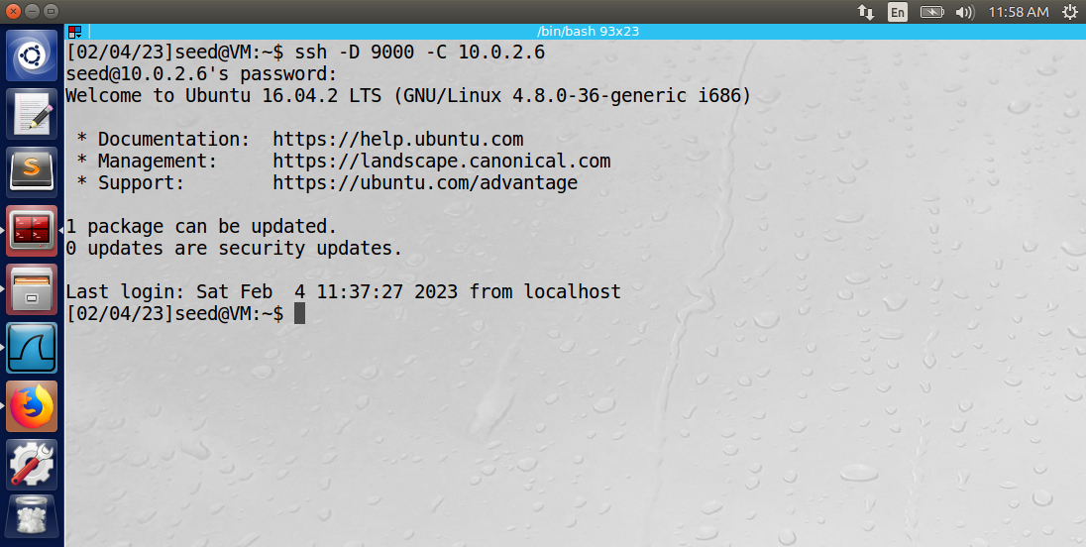

Next, Firefox internet explorer needed to be configured to use port 9000 as its proxy server when attempting to connect to a web server. The lab instructions detail how to set up Firefox using the Edit -> Preferences menu.

1. Firefox was used to successfully access www.syr.edu.

A Wireshark log was created to display the packet content between machine A and the proxy server. The SSH tunnel establishes a connection between machine A (10.0.2.5) and machine B (IP 10.0.2.6) through the proxy server on port 9000. The SSH tunnel bypasses machine A’s firewall. The Wireshark log below displays the TCP packets between the proxy server (IP 142.250.65.202) and machine A (IP 10.0.2.5).

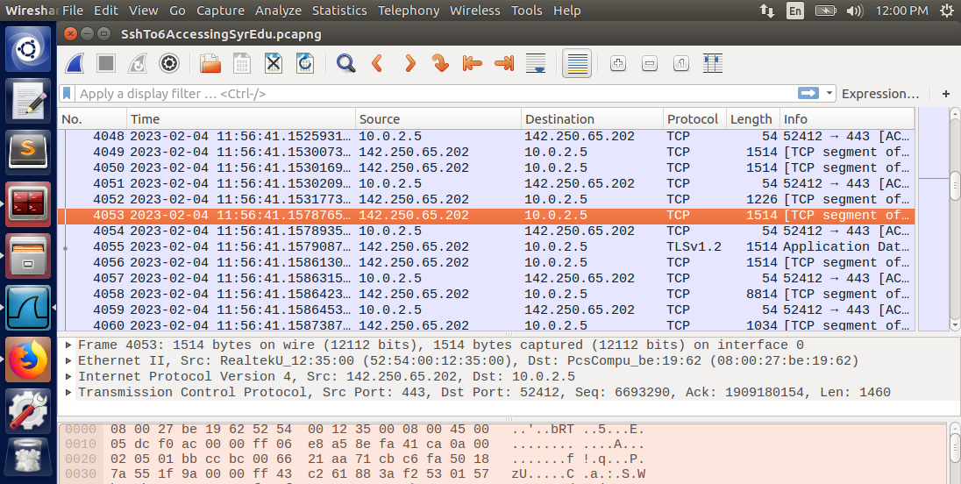

1. The SSH tunnel was then broken, and the Firefox cache was cleared. The connection with www.syr.edu was unsuccessful.

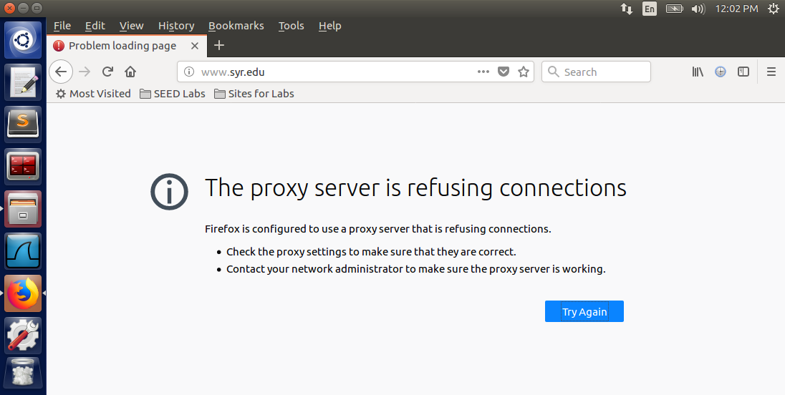

The error message that appeared was “The proxy server is refusing connections.” The Wireshark log below displays the standard DNS packets between machine A and IP 192.168.1.1. Notice that the packets directed to IP 128.230.18.63 (www.syr.edu) have been dropped and are thus not present in the log.

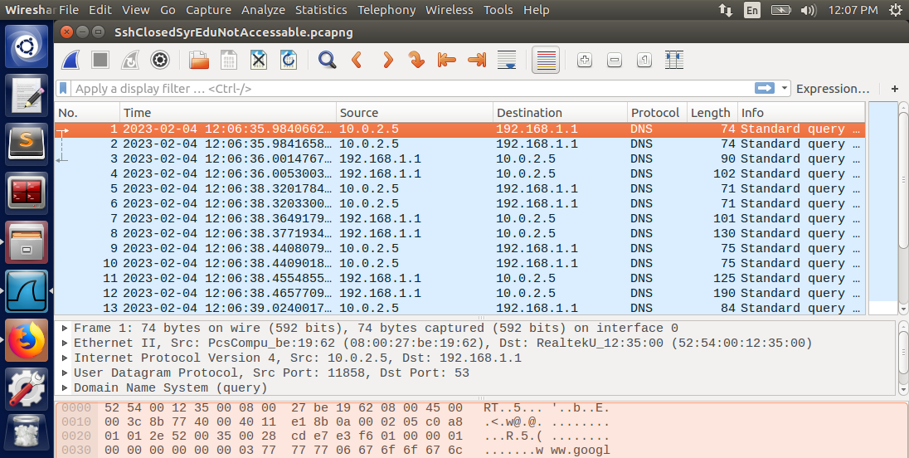

1. The SSH tunnel was reestablished, and Firefox could successfully access www.syr.edu again.

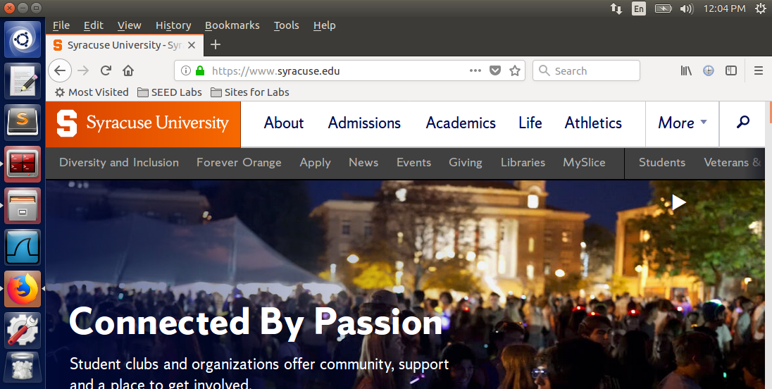

1. The Wireshark logs illustrate the packet traffic with and without the SSH tunnel. The SSH tunnel is established between machine A and machine B through port 9000. The tunnel sends encrypted traffic to machine B, which does not have an egress filter. In this way, the SSH allows the bypassing of the egress filter in machine A’s firewall.

Task 4:

The following firewall rules were used to establish the rules specified in the lab requirements on machine A:

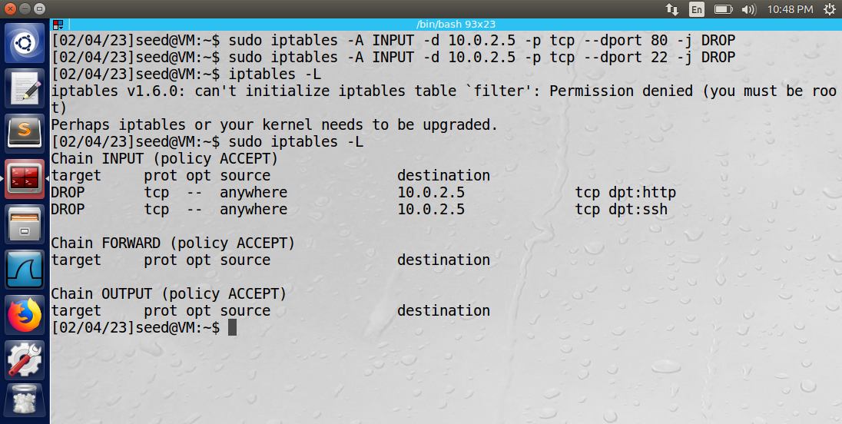

The rules will drop any ingress TCP packets using port 80 (webserver) or port 22 (ssh tunnel). Therefore, no external machines will be able to access machine A’s internal webserver (port 80) or establish an SSH connection using ingress SSH commands (sent to machine A).

Below is machine A’s internal webserver.

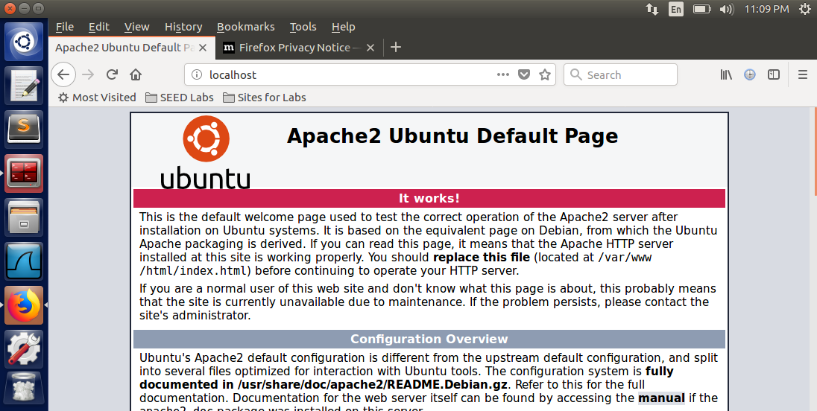

How would machine B access this server on machine A? One method is to use a reverse tunnel established by machine A to machine B. The SSH firewall rule only blocked ingress SSH commands, not egress. The following rule was used to establish the reverse tunnel between machines A and B:

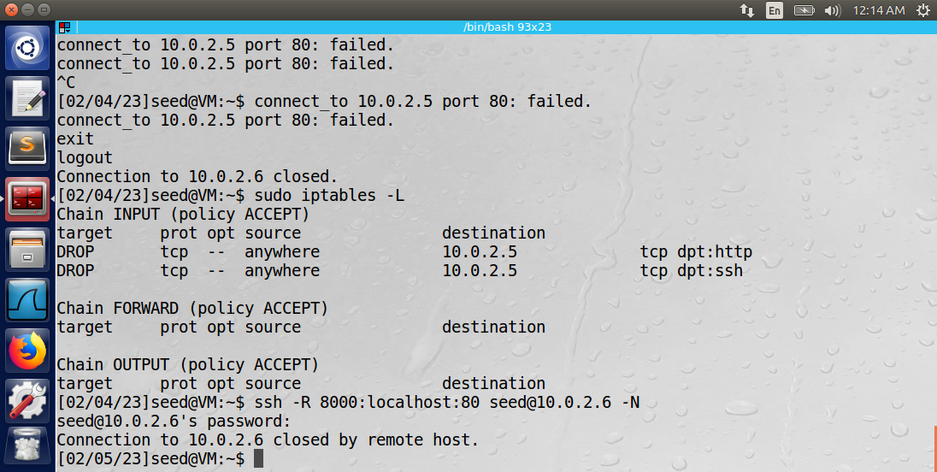

The localhost port 8000 was used to establish the reverse tunnel with seed@10.0.2.6 (machine B). The tunnel forwarded traffic from the localhost server on port 80 of machine A.

Below is a Wireshark log of the traffic taken from enp0s3 on machine A. The SSH traffic is encrypted, so the firewall rule allows the sending of information from the localhost server on port 80 of machine A.

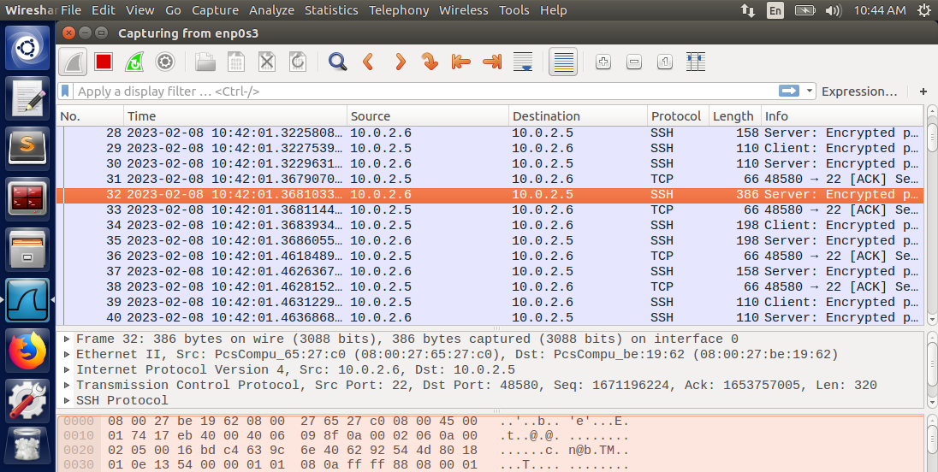

Below is a screenshot of machine B accessing machine A’s localhost server using port 8000.

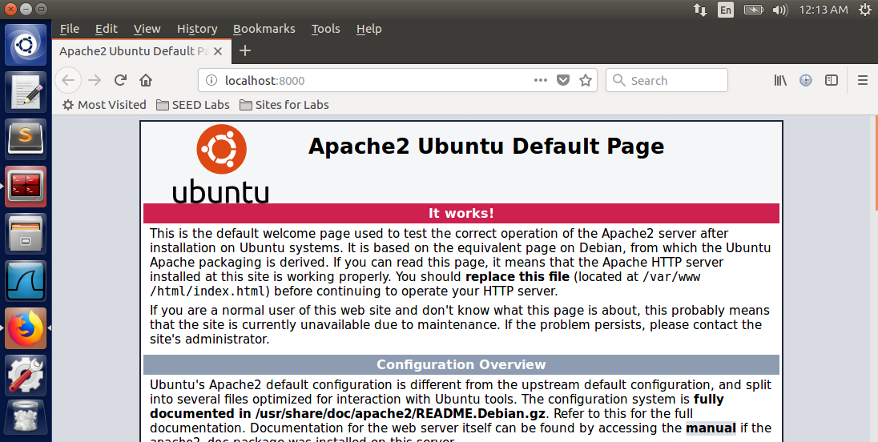

Observation: Machine B was able to access machine A’s localhost server via a reverse tunnel established on port 8000. The reverse tunnel encrypted and forwarded data from the localhost server on port 80 of machine A.

Explanation: By encrypting the packets using an SSH tunnel with machine A, machine B was able to successfully access machine A’s localhost server. Therefore, a reverse SSH tunnel was used in place of a VPN.

Appendix:

**Task 2: task2.c**

// CSE-644: Internet Security

// Dr. Syed Shazli

// Anthony Redamonti

// 2-7-2023

//

// task2.c

#include <linux/kernel.h>

#include <linux/module.h>

#include <linux/netfilter.h>

#include <linux/netfilter_ipv4.h>

#include <linux/ip.h>

#include <linux/tcp.h>

#include <linux/udp.h>

#include <linux/icmp.h>

#include <linux/if_ether.h>

#include <linux/inet.h>

// 6 hooks are needed for 5 rules because one of the rules is used

// to print out the packet information

static struct nf_hook_ops hook1, hook2, hook3, hook4, hook5, hook6;

// blocking ping to destination IP 10.0.2.7

unsigned int blockIcmpTo7(void *priv, struct sk_buff *skb,

                       const struct nf_hook_state *state)

{

   struct iphdr *iph;

   struct icmphdr *icmph;

   char destIp[16] = "10.0.2.7";

   u32  ip_addr;

   if (!skb) return NF_ACCEPT;

   iph = ip_hdr(skb);

   // Convert the IPv4 address from dotted decimal to 32-bit binary

   in4_pton(destIp, -1, (u8 *)&ip_addr, '\0', NULL);

   if (iph->protocol == IPPROTO_ICMP) {

       icmph = icmp_hdr(skb);

       if (iph->daddr == ip_addr && icmph->type == ICMP_ECHO){

            printk(KERN_WARNING "*** Dropping %pI4 (ICMP) \n", &(iph->daddr));

            return NF_DROP;

        }

   }

   return NF_ACCEPT;

}

// blocking ping from destination IP 10.0.2.7

unsigned int blockIcmpFrom7(void *priv, struct sk_buff *skb,

                       const struct nf_hook_state *state)

{

   struct iphdr *iph;

   struct icmphdr *icmph;

   char srcIp[16] = "10.0.2.7";

   u32  ip_addr;

   if (!skb) return NF_ACCEPT;

   iph = ip_hdr(skb);

   // Convert the IPv4 address from dotted decimal to 32-bit binary

   in4_pton(srcIp, -1, (u8 *)&ip_addr, '\0', NULL);

   if (iph->protocol == IPPROTO_ICMP) {

       icmph = icmp_hdr(skb);

       if (iph->saddr == ip_addr && icmph->type == ICMP_ECHO){

            printk(KERN_WARNING "*** Dropping %pI4 (ICMP) \n", &(iph->daddr));

            return NF_DROP;

        }

   }

   return NF_ACCEPT;

}

// blocking telnet to 10.0.2.7 : 23

unsigned int blockTelnetTo7(void *priv, struct sk_buff *skb,

                       const struct nf_hook_state *state)

{

   struct iphdr *iph;

   struct tcphdr *tcph;

   u16  port   = 23;

   char ip[16] = "10.0.2.7";

   u32  ip_addr;

   if (!skb) return NF_ACCEPT;

   iph = ip_hdr(skb);

   // Convert the IPv4 address from dotted decimal to 32-bit binary

   in4_pton(ip, -1, (u8 *)&ip_addr, '\0', NULL);

   if (iph->protocol == IPPROTO_TCP) {

       tcph = tcp_hdr(skb);

       if (iph->daddr == ip_addr && ntohs(tcph->dest) == port){

            printk(KERN_WARNING "*** Dropping %pI4 (TCP), port %d\n", &(iph->daddr), port);

            return NF_DROP;

        }

   }

   return NF_ACCEPT;

}

// blocking telnet from 10.0.2.7 : 23

unsigned int blockTelnetFrom7(void *priv, struct sk_buff *skb,

                       const struct nf_hook_state *state)

{

   struct iphdr *iph;

   struct tcphdr *tcph;

   u16  port   = 23;

   char ip[16] = "10.0.2.7";

   u32  ip_addr;

   if (!skb) return NF_ACCEPT;

   iph = ip_hdr(skb);

   // Convert the IPv4 address from dotted decimal to 32-bit binary

   in4_pton(ip, -1, (u8 *)&ip_addr, '\0', NULL);

   if (iph->protocol == IPPROTO_TCP) {

       tcph = tcp_hdr(skb);

       if (iph->saddr == ip_addr && ntohs(tcph->dest) == port){

            printk(KERN_WARNING "*** Dropping %pI4 (TCP), port %d\n", &(iph->daddr), port);

            return NF_DROP;

        }

   }

   return NF_ACCEPT;

}

// blocking telnet from 10.0.2.6 : 23

unsigned int blockTelnetFrom6(void *priv, struct sk_buff *skb,

                       const struct nf_hook_state *state)

{

   struct iphdr *iph;

   struct tcphdr *tcph;

   u16  port   = 23;

   char ip[16] = "10.0.2.6";

   u32  ip_addr;

   if (!skb) return NF_ACCEPT;

   iph = ip_hdr(skb);

   // Convert the IPv4 address from dotted decimal to 32-bit binary

   in4_pton(ip, -1, (u8 *)&ip_addr, '\0', NULL);

   if (iph->protocol == IPPROTO_TCP) {

       tcph = tcp_hdr(skb);

       if (iph->saddr == ip_addr && ntohs(tcph->dest) == port){

            printk(KERN_WARNING "*** Dropping %pI4 (TCP), port %d\n", &(iph->daddr), port);

            return NF_DROP;

        }

   }

   return NF_ACCEPT;

}

// print the packet information to the log file.

unsigned int printInfo(void *priv, struct sk_buff *skb,

                 const struct nf_hook_state *state)

{

   struct iphdr *iph;

   char *hook;

   char *protocol;

   switch (state->hook){

     case NF_INET_LOCAL_IN:     hook = "LOCAL_IN";     break;

     case NF_INET_LOCAL_OUT:    hook = "LOCAL_OUT";    break;

     case NF_INET_PRE_ROUTING:  hook = "PRE_ROUTING";  break;

     case NF_INET_POST_ROUTING: hook = "POST_ROUTING"; break;

     case NF_INET_FORWARD:      hook = "FORWARD";      break;

     default:                   hook = "IMPOSSIBLE";   break;

   }

   printk(KERN_INFO "*** %s\n", hook);

   iph = ip_hdr(skb);

   switch (iph->protocol){

     case IPPROTO_UDP:  protocol = "UDP";   break;

     case IPPROTO_TCP:  protocol = "TCP";   break;

     case IPPROTO_ICMP: protocol = "ICMP";  break;

     default:           protocol = "OTHER"; break;

   }

   // Print out the IP addresses and protocol

   printk(KERN_INFO "    %pI4  --> %pI4 (%s)\n",

                    &(iph->saddr), &(iph->daddr), protocol);

   return NF_ACCEPT;

}

int registerFilter(void) {

   printk(KERN_INFO "Registering filters.\n");

   // hook 1 = print packet information

   hook1.hook = printInfo;

   hook1.hooknum = NF_INET_LOCAL_OUT;

   hook1.pf = PF_INET;

   hook1.priority = NF_IP_PRI_FIRST;

   nf_register_net_hook(&init_net, &hook1);

   // hook 2 = block ICMP to 10.0.2.7

   hook2.hook = blockIcmpTo7;

   hook2.hooknum = NF_INET_LOCAL_OUT;

   hook2.pf = PF_INET;

   hook2.priority = NF_IP_PRI_FIRST;

   nf_register_net_hook(&init_net, &hook2);

   // hook 3 = block ICMP from 10.0.2.7

   hook3.hook = blockIcmpFrom7;

   hook3.hooknum = NF_INET_LOCAL_IN;

   hook3.pf = PF_INET;

   hook3.priority = NF_IP_PRI_FIRST;

   nf_register_net_hook(&init_net, &hook3);

   // hook 4 = block telnet to 10.0.2.7

   hook4.hook = blockTelnetTo7;

   hook4.hooknum = NF_INET_LOCAL_OUT;

   hook4.pf = PF_INET;

   hook4.priority = NF_IP_PRI_FIRST;

   nf_register_net_hook(&init_net, &hook4);

   // hook 5 = block telnet from 10.0.2.7

   hook5.hook = blockTelnetFrom7;

   hook5.hooknum = NF_INET_LOCAL_IN;

   hook5.pf = PF_INET;

   hook5.priority = NF_IP_PRI_FIRST;

   nf_register_net_hook(&init_net, &hook5);

   // hook 6 = block telnet from 10.0.2.6

   hook6.hook = blockTelnetFrom6;

   hook6.hooknum = NF_INET_LOCAL_IN;

   hook6.pf = PF_INET;

   hook6.priority = NF_IP_PRI_FIRST;

   nf_register_net_hook(&init_net, &hook6);

   return 0;

}

// remove the hooks from the module

void removeFilter(void) {

   printk(KERN_INFO "The filters are being removed.\n");

   nf_unregister_net_hook(&init_net, &hook1);

   nf_unregister_net_hook(&init_net, &hook2);

   nf_unregister_net_hook(&init_net, &hook3);

   nf_unregister_net_hook(&init_net, &hook4);

   nf_unregister_net_hook(&init_net, &hook5);

   nf_unregister_net_hook(&init_net, &hook6);

}

module_init(registerFilter);

module_exit(removeFilter);

MODULE_LICENSE("GPL");

**Task 2: Makefile**

obj-m += seedBlock.o

all:

    make -C /lib/modules/$(shell uname -r)/build M=$(PWD) modules

clean:

    make -C /lib/modules/$(shell uname -r)/build M=$(PWD) clean

ins:

    sudo dmesg -C

    sudo insmod seedFilter.ko

rm:

    sudo rmmod seedFilter